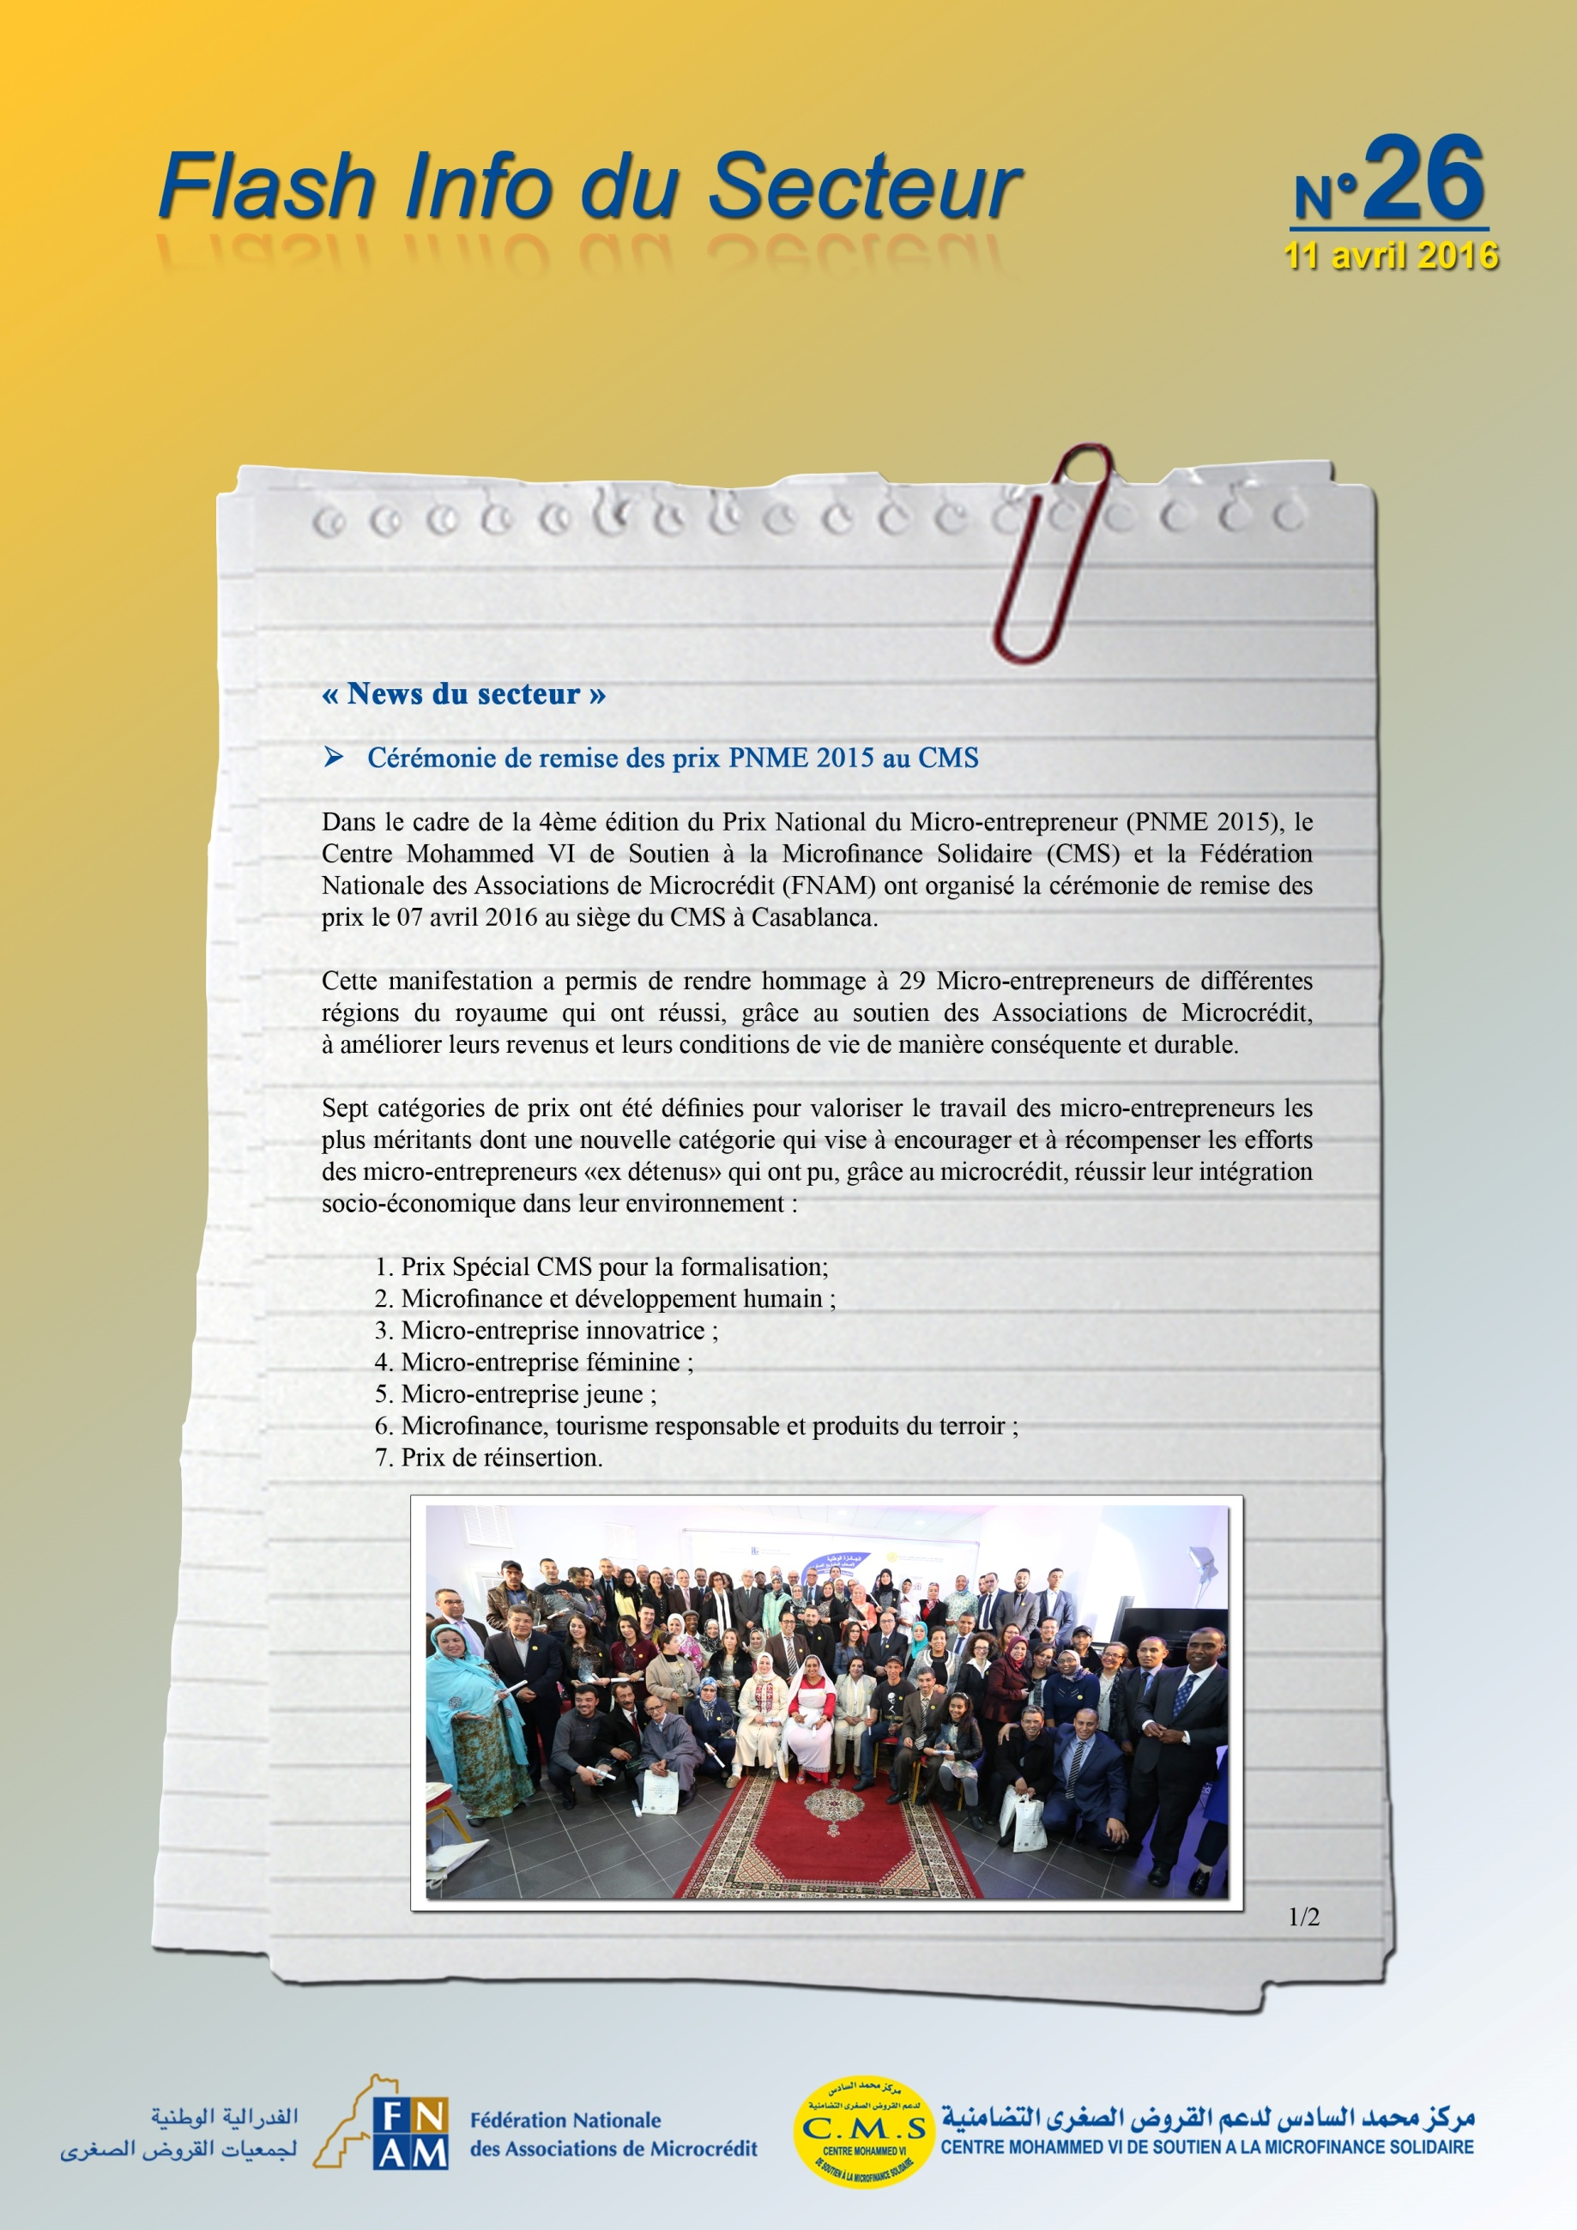

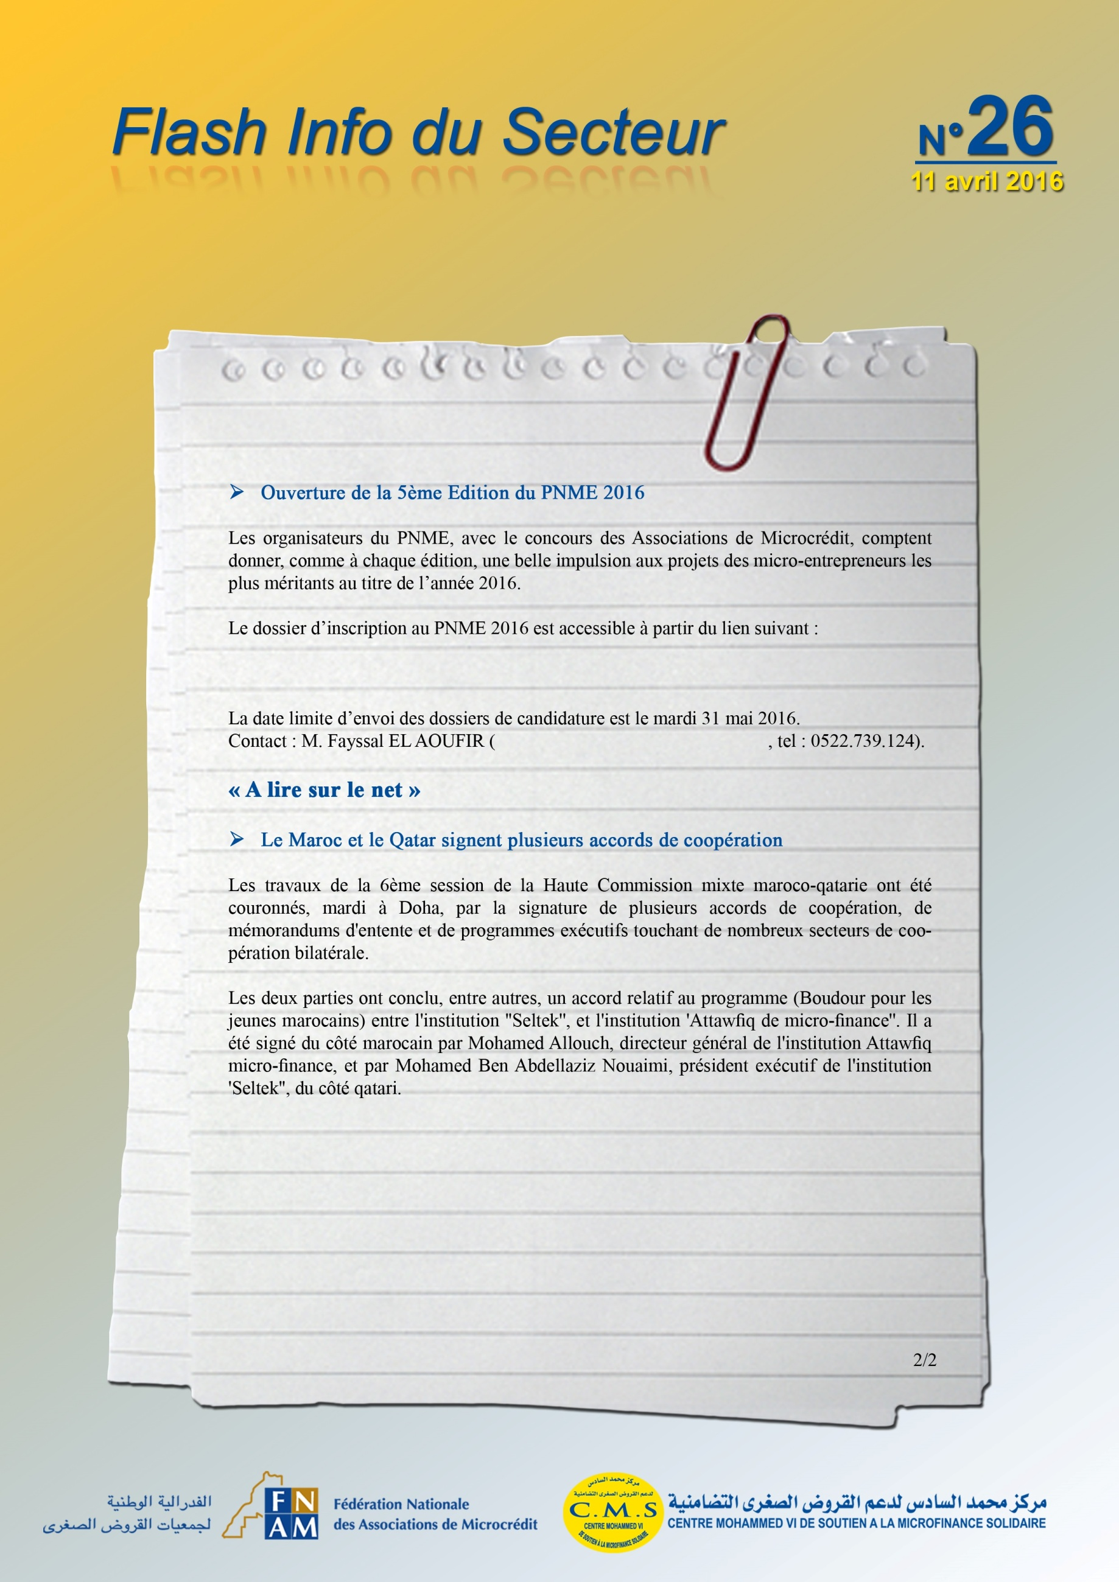
http://www.cm6-microfinance.ma/fr/agenda.aspx
f.elaoufir@cmsms.org.ma
http://www.yabiladi.com/articles/details/43670/maroc-qatar-signent-plusieurs-accords.html

