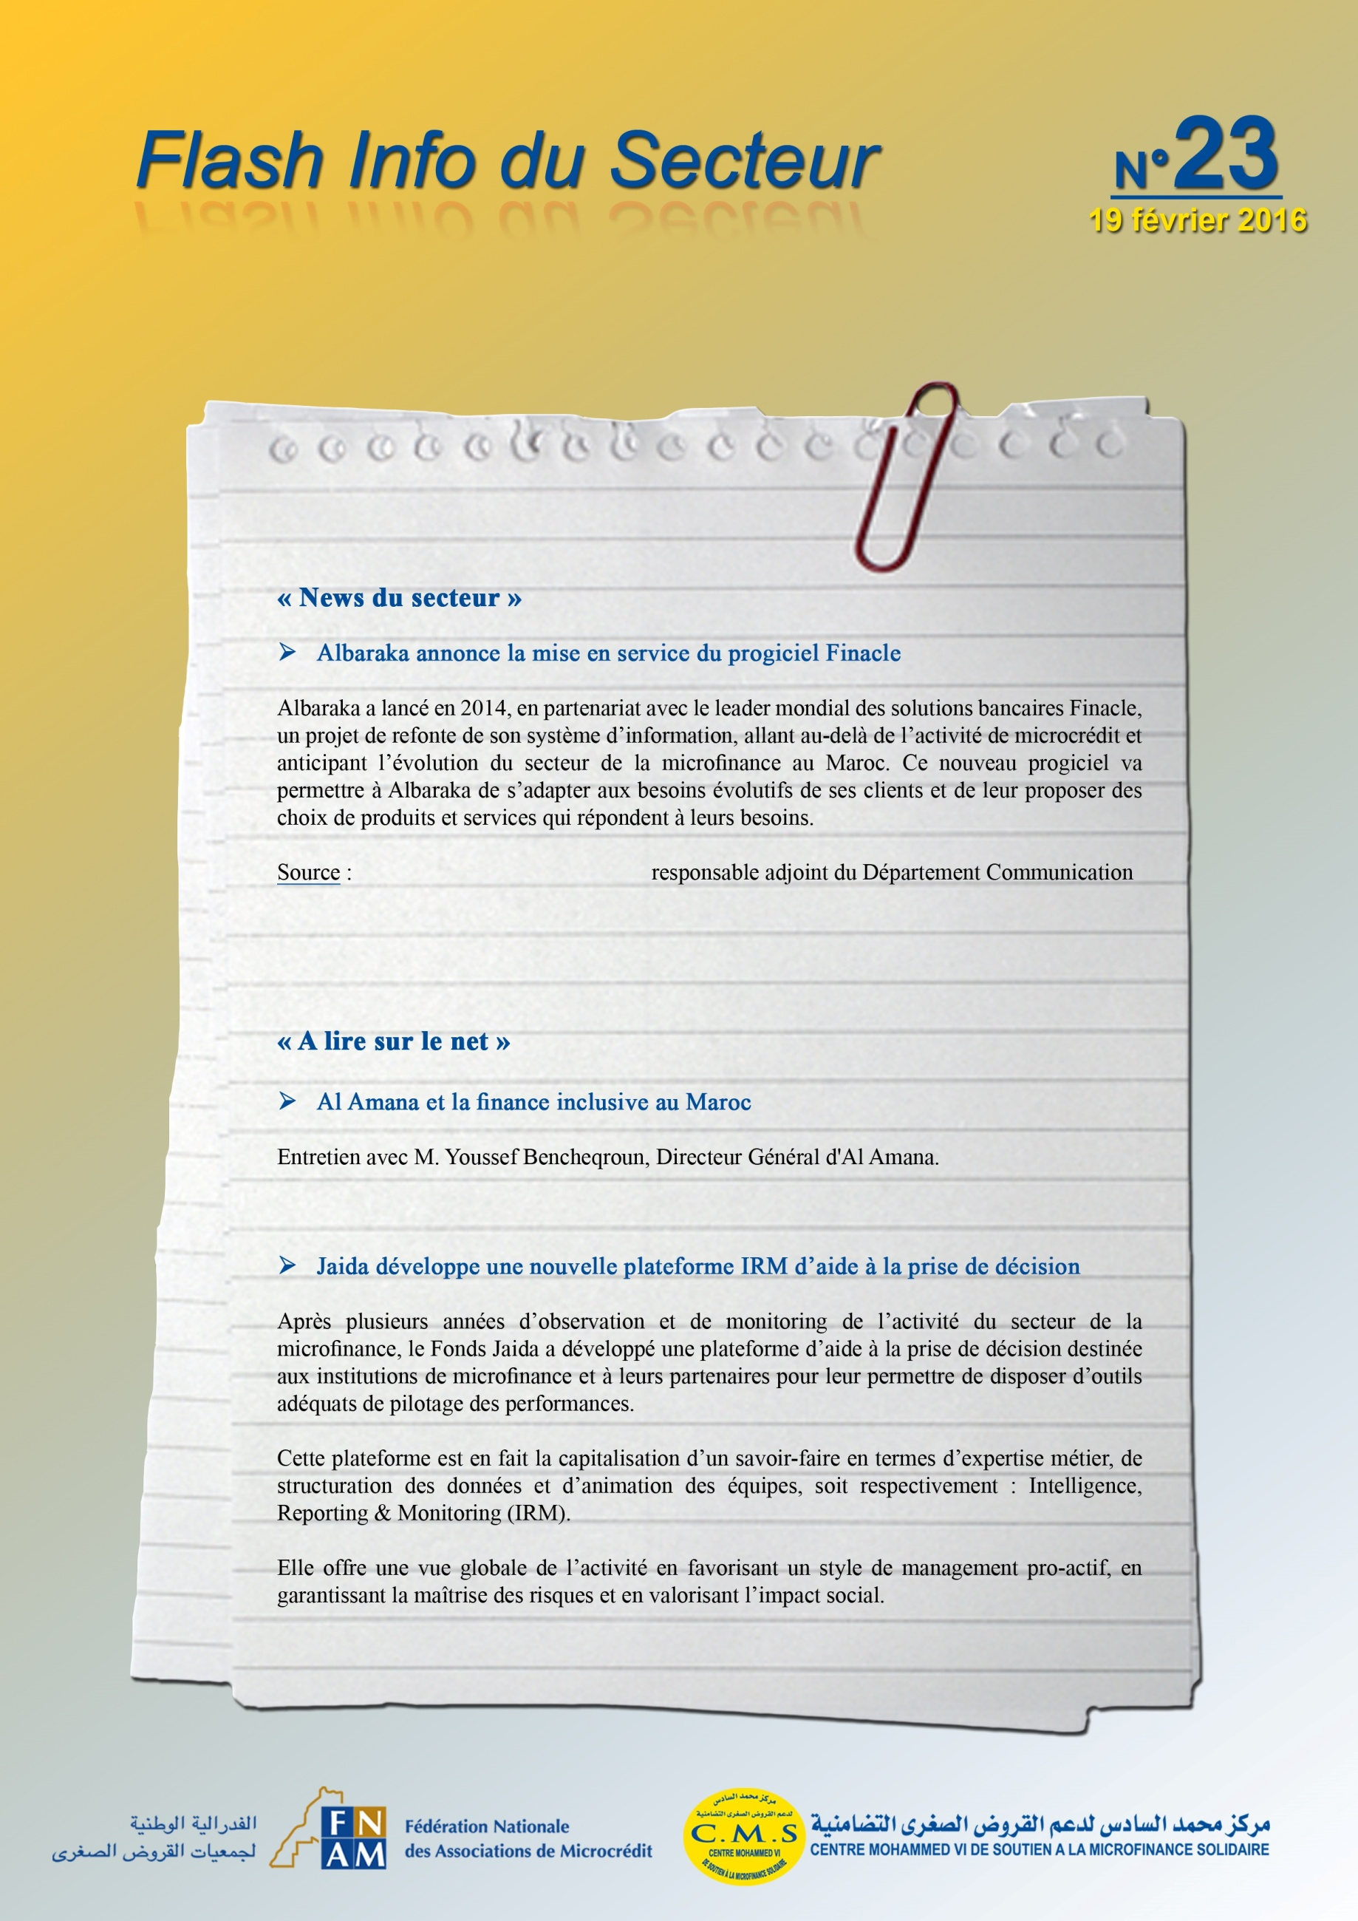
manal.chraibi@albaraka.ma,
http://www.lelezard.com/communique-9400462.html

http://www.microfinancegateway.org/fr/library/al-amana-et-la-finance-inclusive-au-maroc

http://www.microfinance.ma/wp-content/uploads/2015/12/IRM.pdf

