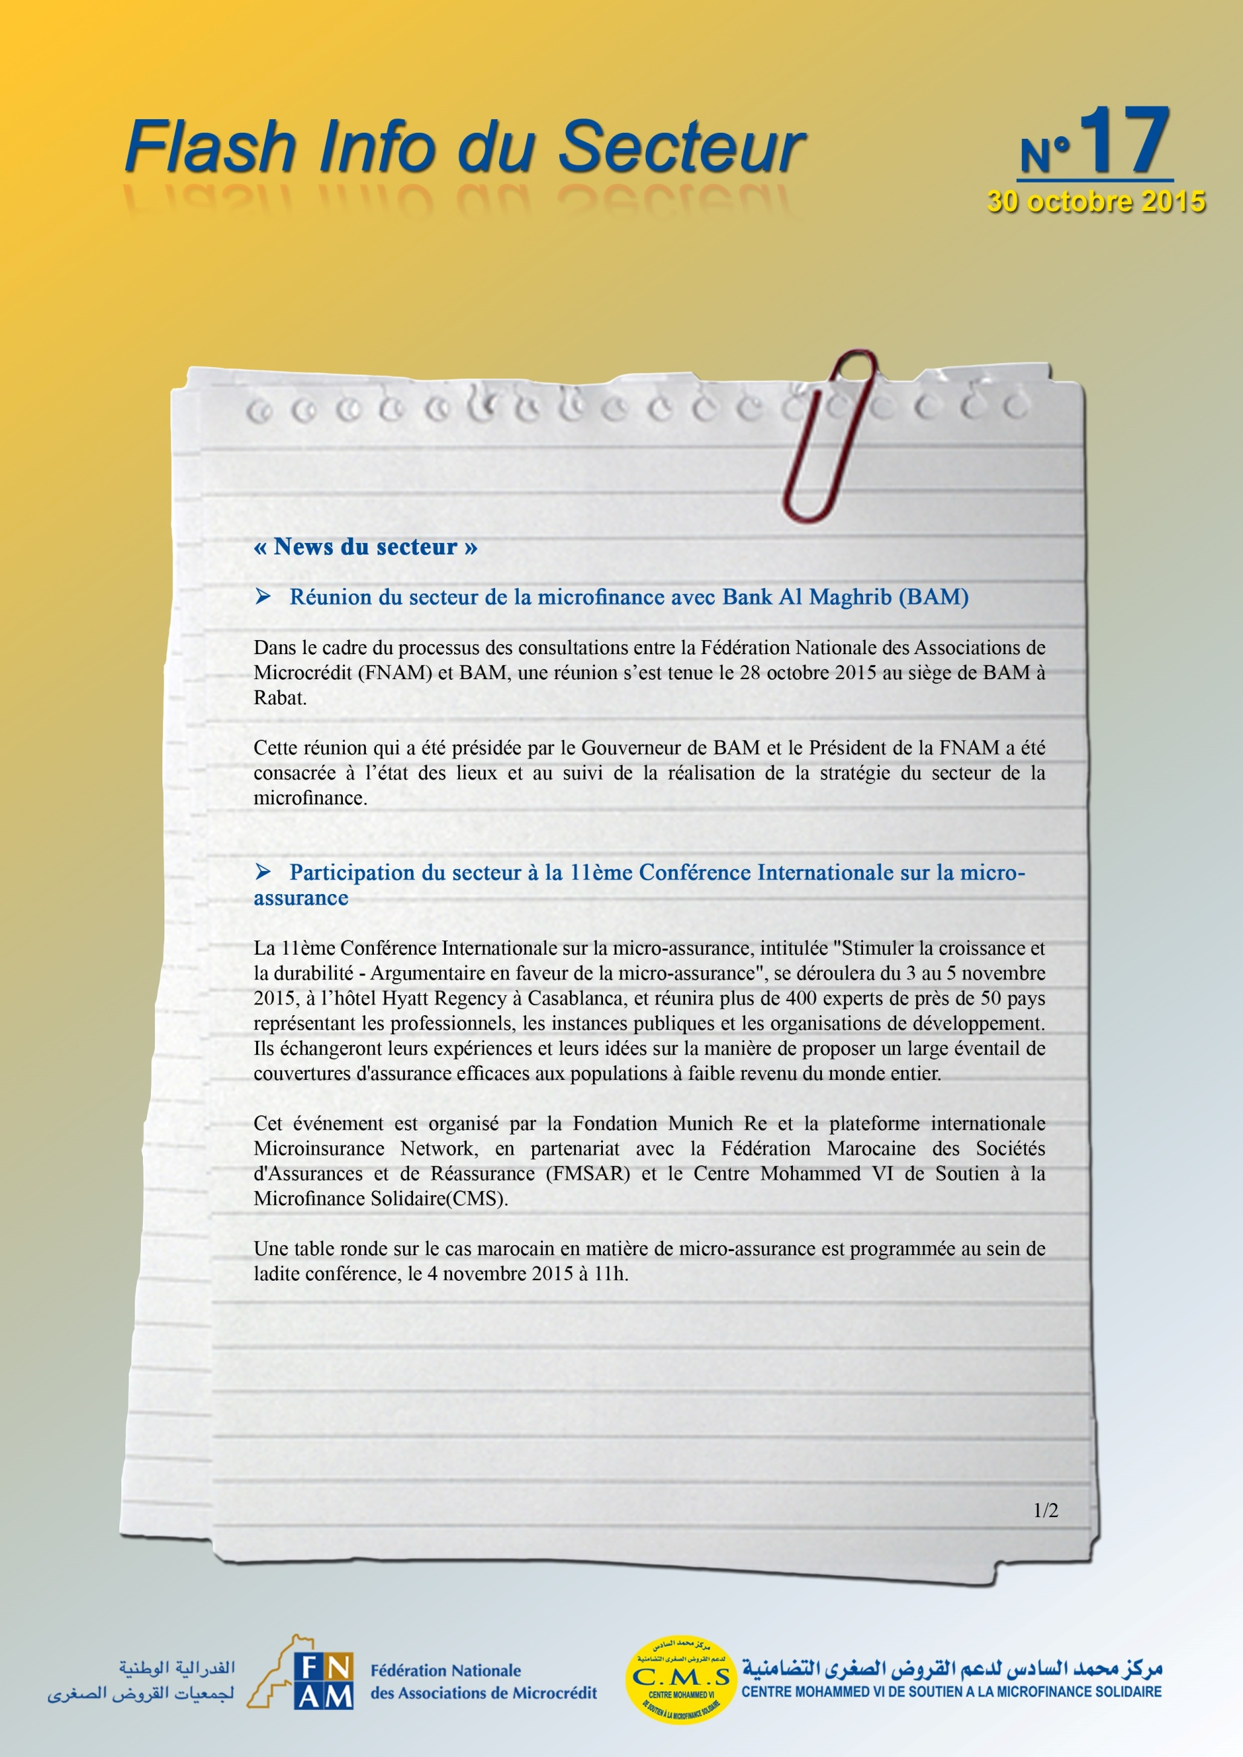
http://www.microinsurancenetwork.org/sites/default/files/files/11th%20IMC%20Press%20Release_FR_28%20October%202015.pdf

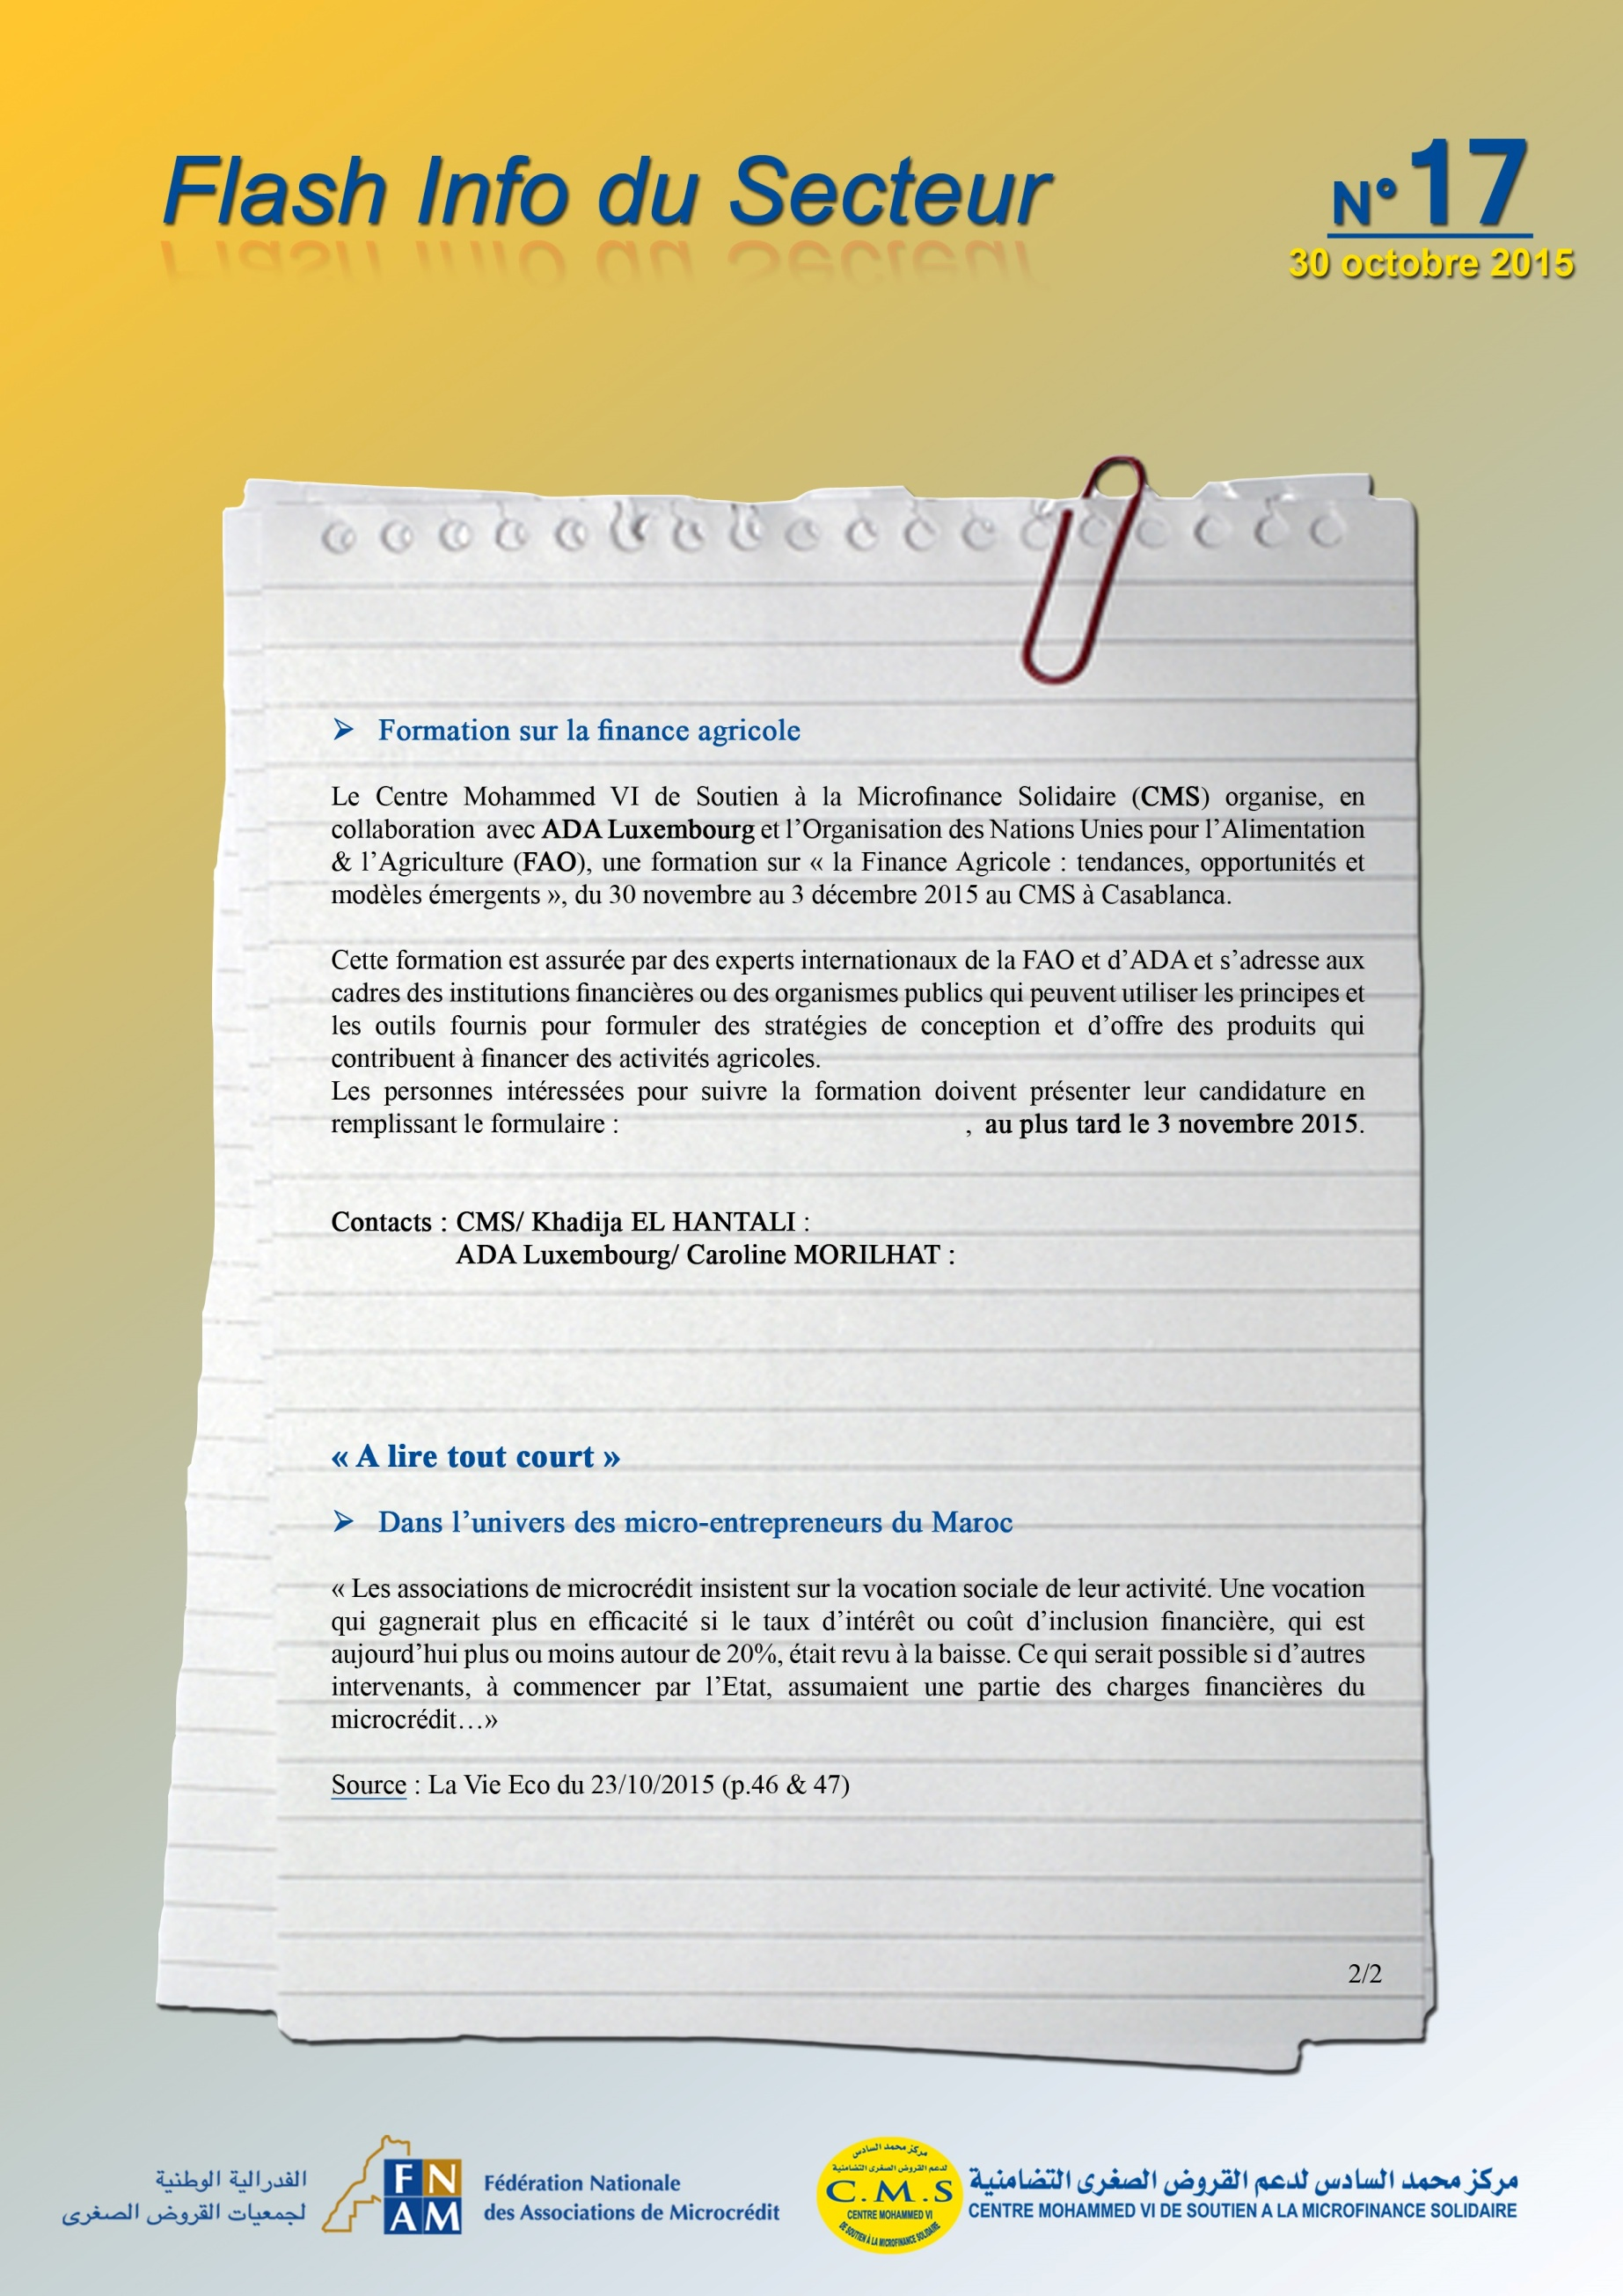
k.elhantali@cmsms.org.ma
http://bit.ly/1LxQCy2
c.morilhat@ada-microfinance.lu
http://www.lavieeco.com/news/societe/dans-l-univers-des-micro-entrepreneurs-du-maroc-35716.html

