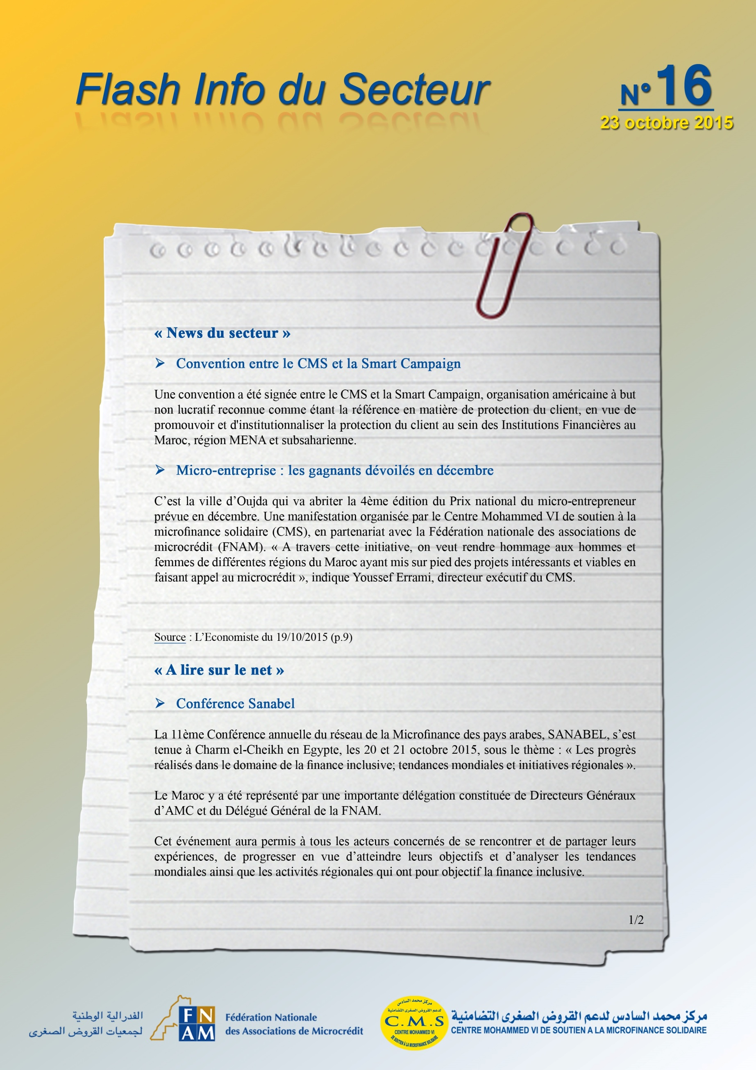
http://www.leconomiste.com/article/978763-micro-entrepriseles-gagnants-devoiles-en-decembre
http://www.sanabelconf.org/Default_fr.aspx
http://lematin.ma/journal/2015/le-maroc-en-force-a-la-conference--de-sanabel-2015/233593.html

