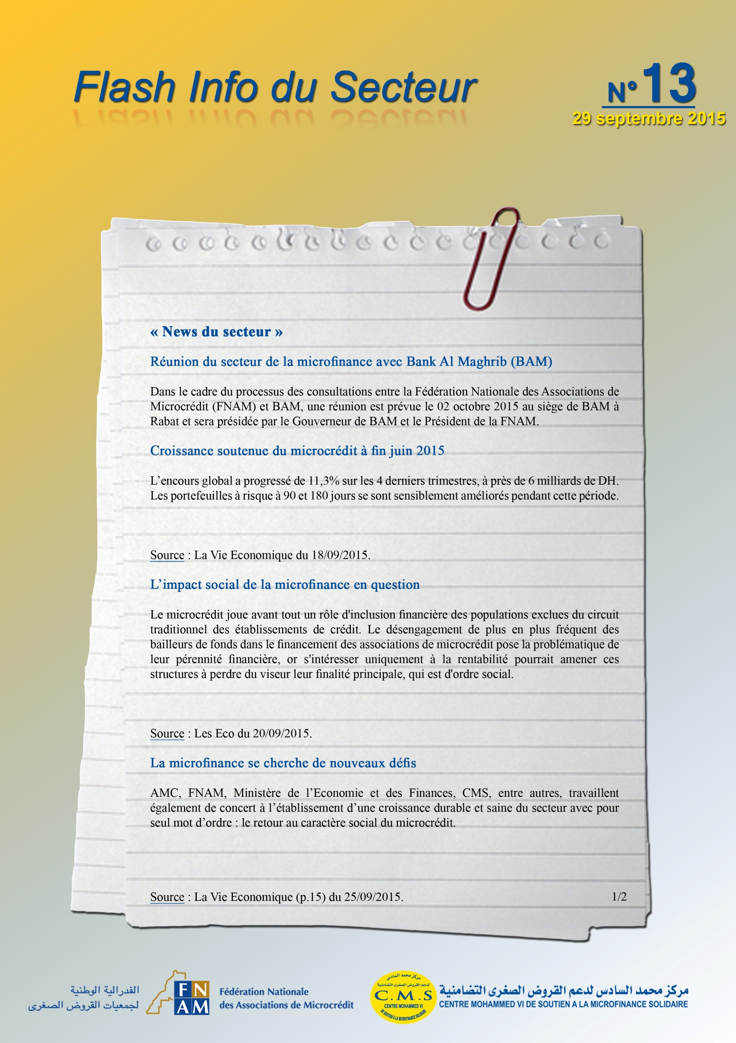
http://www.lavieeco.com/news/economie/croissance-soutenue-du-microcredit-a-fin-juin-35296.html

http://www.leseco.ma/finances/37004-l-impact-social-de-la-microfinance-en-question.html

