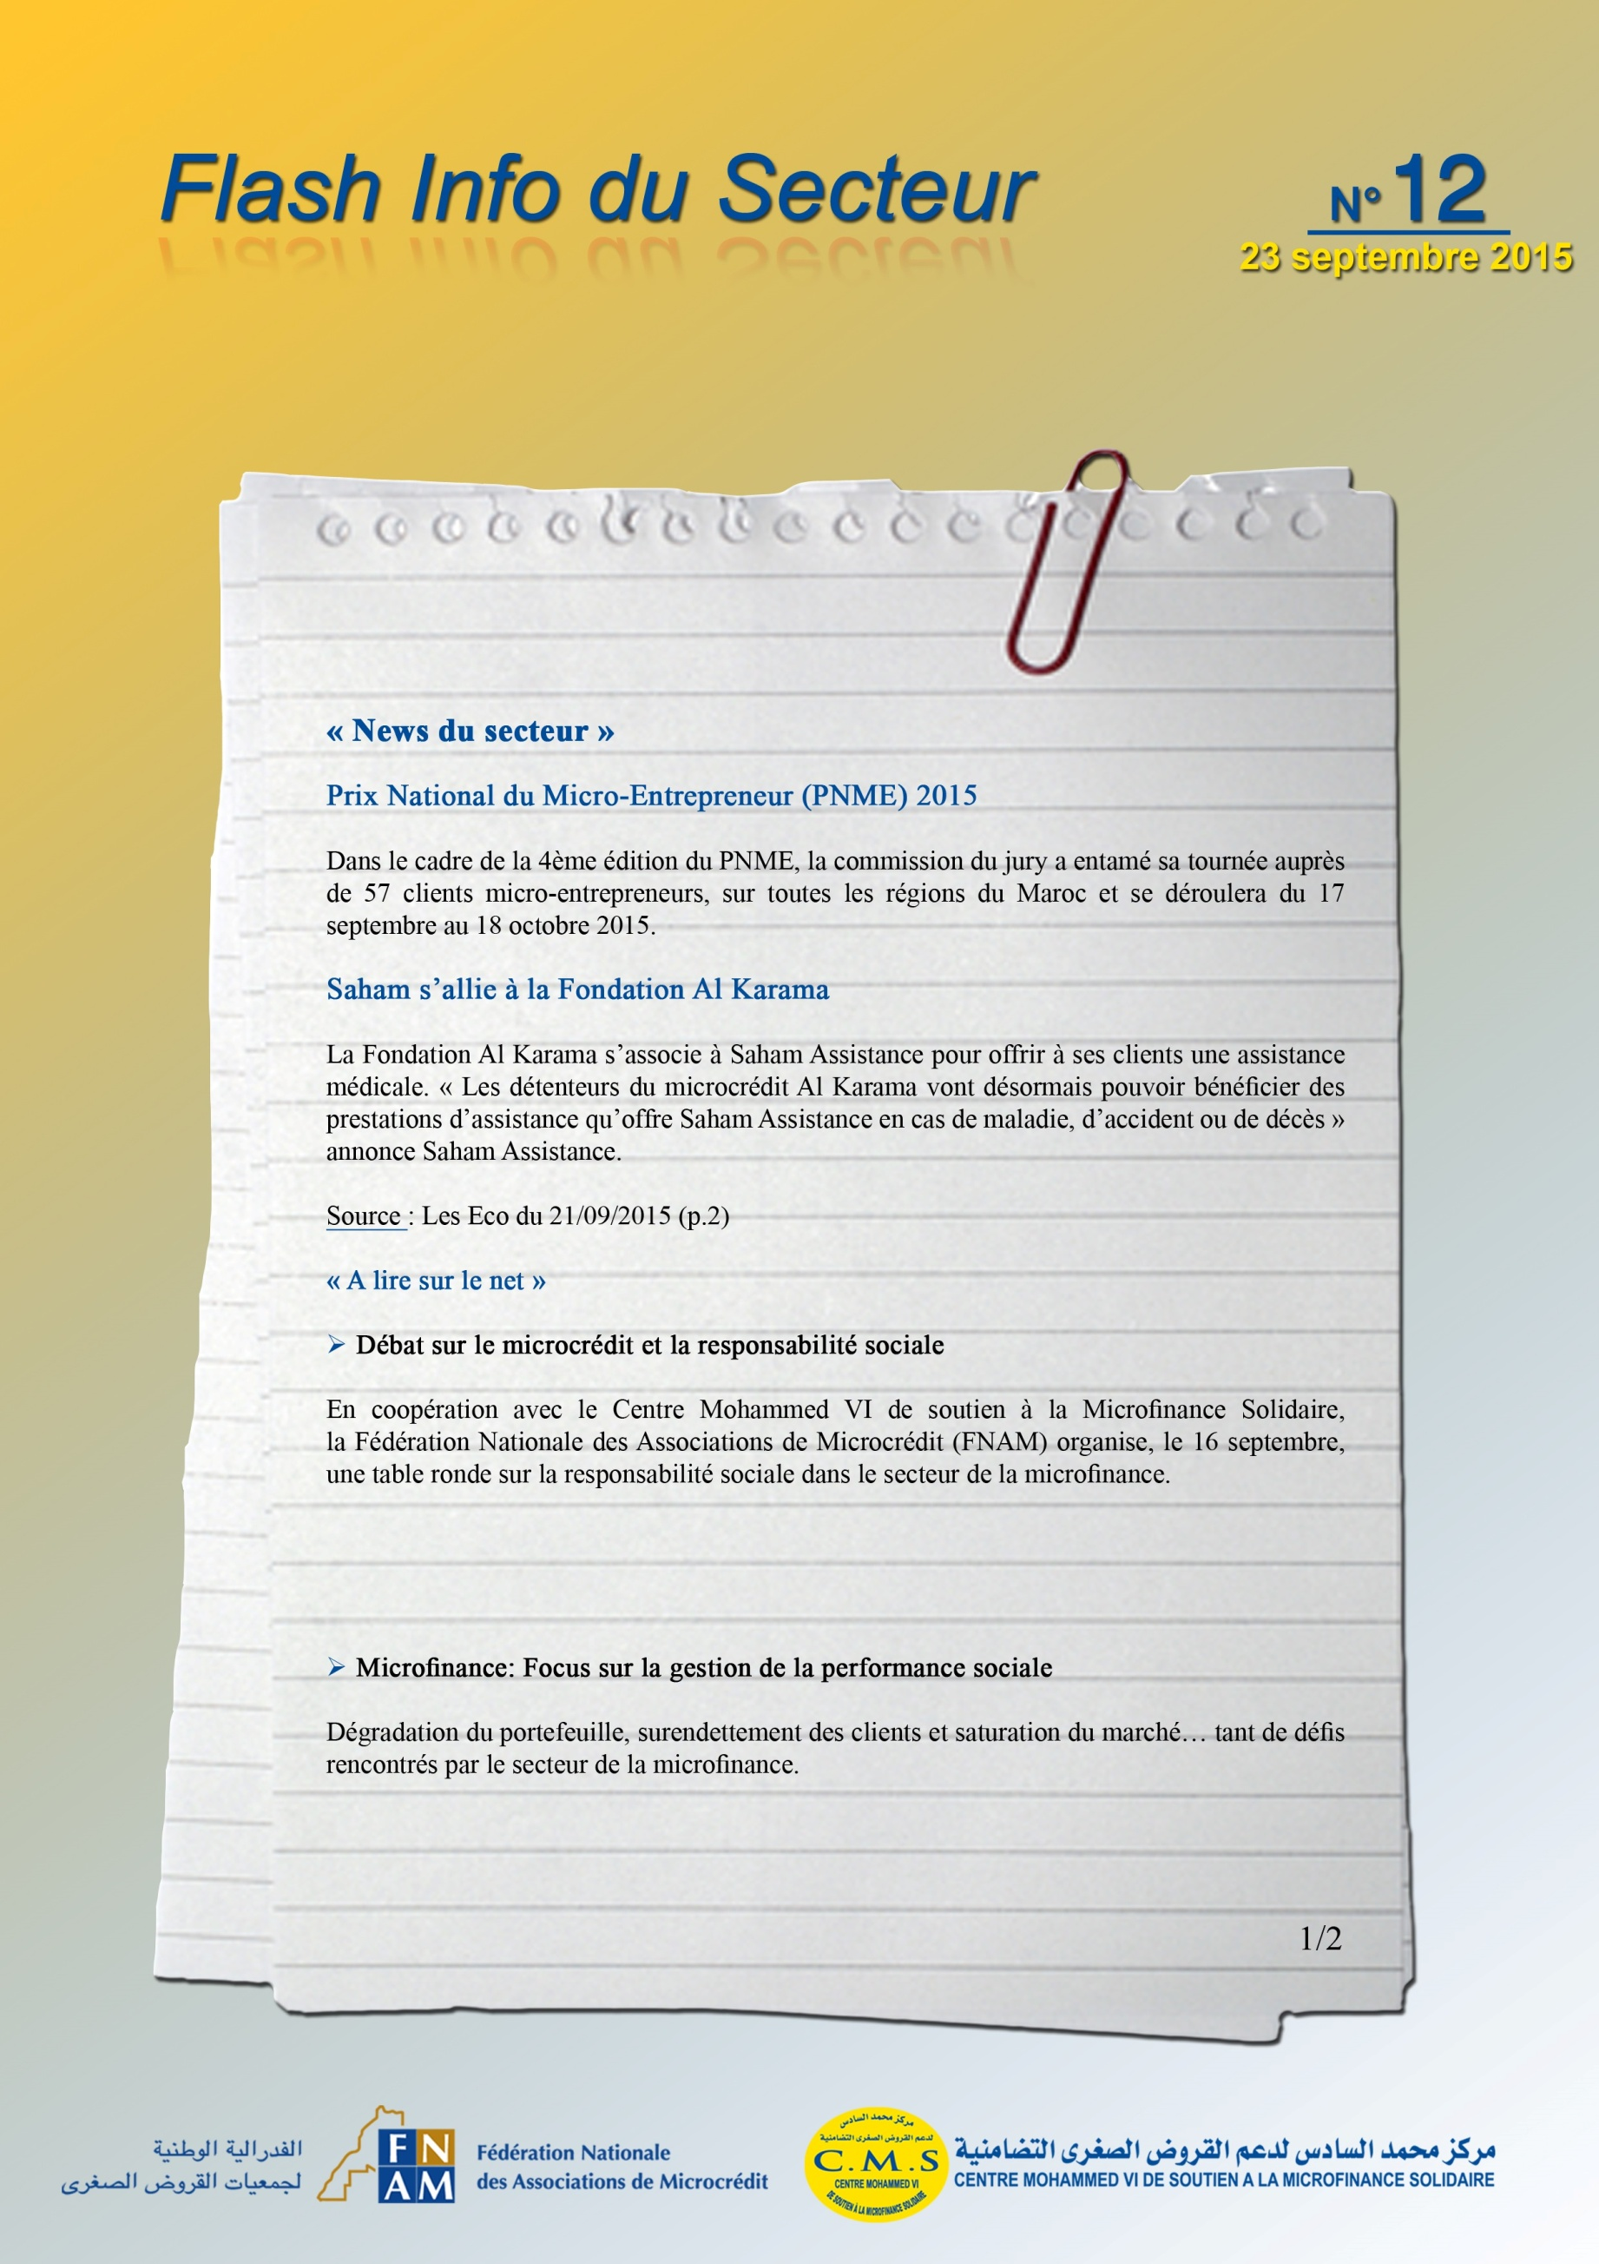
http://www.lavieeco.com/news/actualites/debat-sur-le-microcredit-et-la-responsabilite-sociale-35233.html

